SIMATS ENGINEERING (SAVEETHA SCHOOL OF ENGINEERING)
Course Code & Title: | ECA5604 -5G/6G COMMUNICATION | Course Faculty: | Dr.K.Sathish
Student Name: | Velamuri Bhanodhay | Reg. No.: | 192412330
Dept / Batch: | BE.ECE / 2024 | Date: | 19/8/2026
Lab Observation

Experiment 13 :V2X Latency Comparison

Objective 1: To evaluate the End-to-End Latency (ms) of a V2X communication system under
different vehicle operating conditions.

Matlab Code:

clc;clear;close all
S=20:20:120; L=[18 16 14 12 10 9];
disp('Speed(km/h) Latency(ms)'),disp([S' L'])
subplot(211)
plot(S,L,'-o','LineWidth',2);grid on
title('Vehicle Speed vs End-to-End Latency')
xlabel('Vehicle Speed (km/h)'),ylabel('Latency (ms)')
subplot(212)
plot(1:6,L,'-s','LineWidth',2);grid on
title('Latency Variation Across Vehicles')
xlabel('Vehicle Index'),ylabel('End-to-End Latency (ms)')

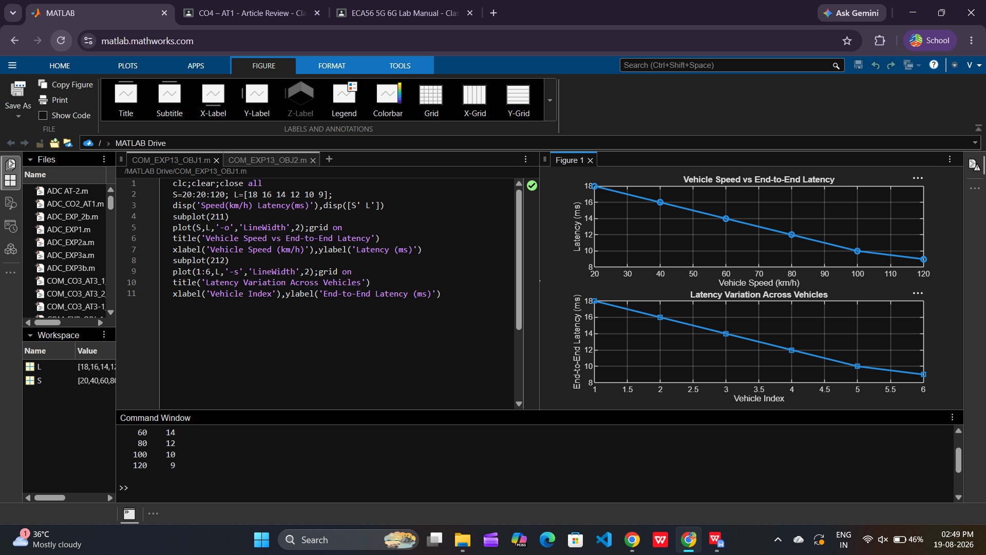

Objective 2: To analyze the Packet Delivery Ratio (%) and determine the reliability of V2X
communication during data transmission.

Matlab Code:

clc;clear;close all
S=20:20:120; P=[99 98 97 95 93 90];
disp('Speed(km/h) PDR(%)'),disp([S' P'])
subplot(211)
plot(S,P,'-o','LineWidth',2);grid on
title('Vehicle Speed vs Packet Delivery Ratio')
xlabel('Vehicle Speed (km/h)'),ylabel('PDR (%)')
subplot(212)
plot(1:6,P,'-s','LineWidth',2);grid on
title('Packet Delivery Ratio Across Vehicles')
xlabel('Vehicle Index'),ylabel('Packet Delivery Ratio (%)')

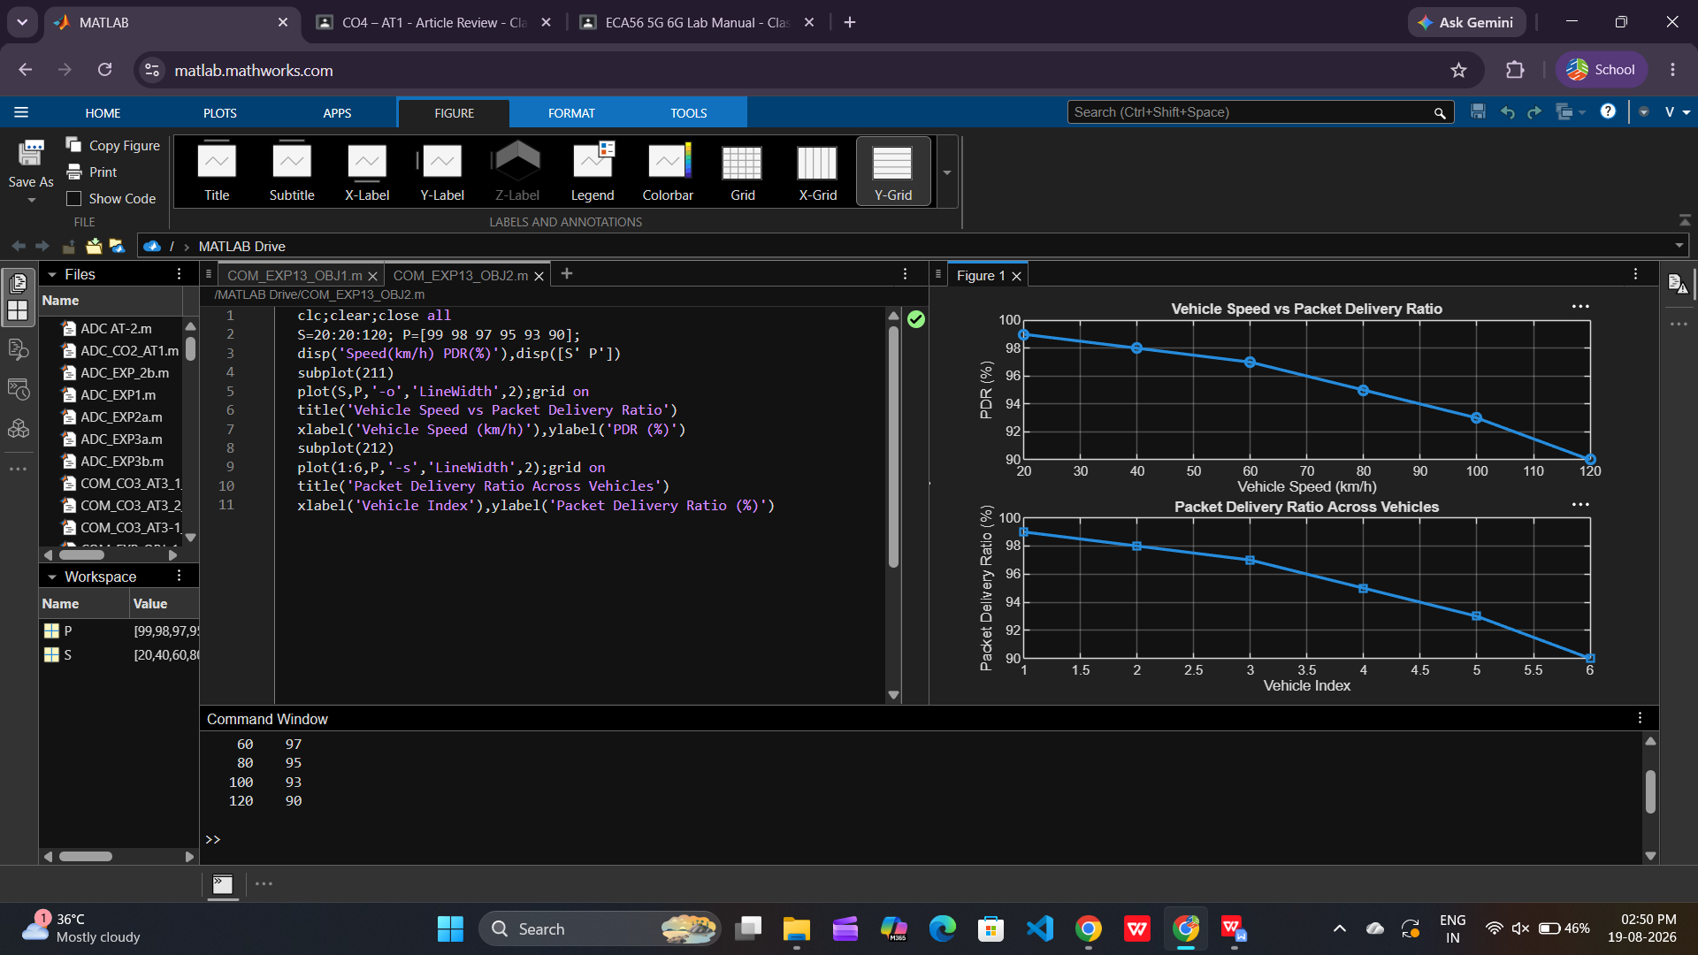

Objective 3: To study the impact of Vehicle Speed (km/h) on the communication performance and
stability of the V2X network.

Matlab Code:

clc;clear;close all
V=1:6; S=[30 45 60 75 90 105];
R=[280 260 240 220 200 180];
disp('Speed(km/h) Range(m)'),disp([S' R'])
subplot(211)
plot(V,S,'-o','LineWidth',2);grid on
title('Vehicle Speed of Different Vehicles')
xlabel('Vehicle Index'),ylabel('Vehicle Speed (km/h)')
subplot(212)
plot(S,R,'-s','LineWidth',2);grid on
title('Vehicle Speed vs Communication Range')
xlabel('Vehicle Speed (km/h)'),ylabel('Communication Range (m)')

